Supplementary information
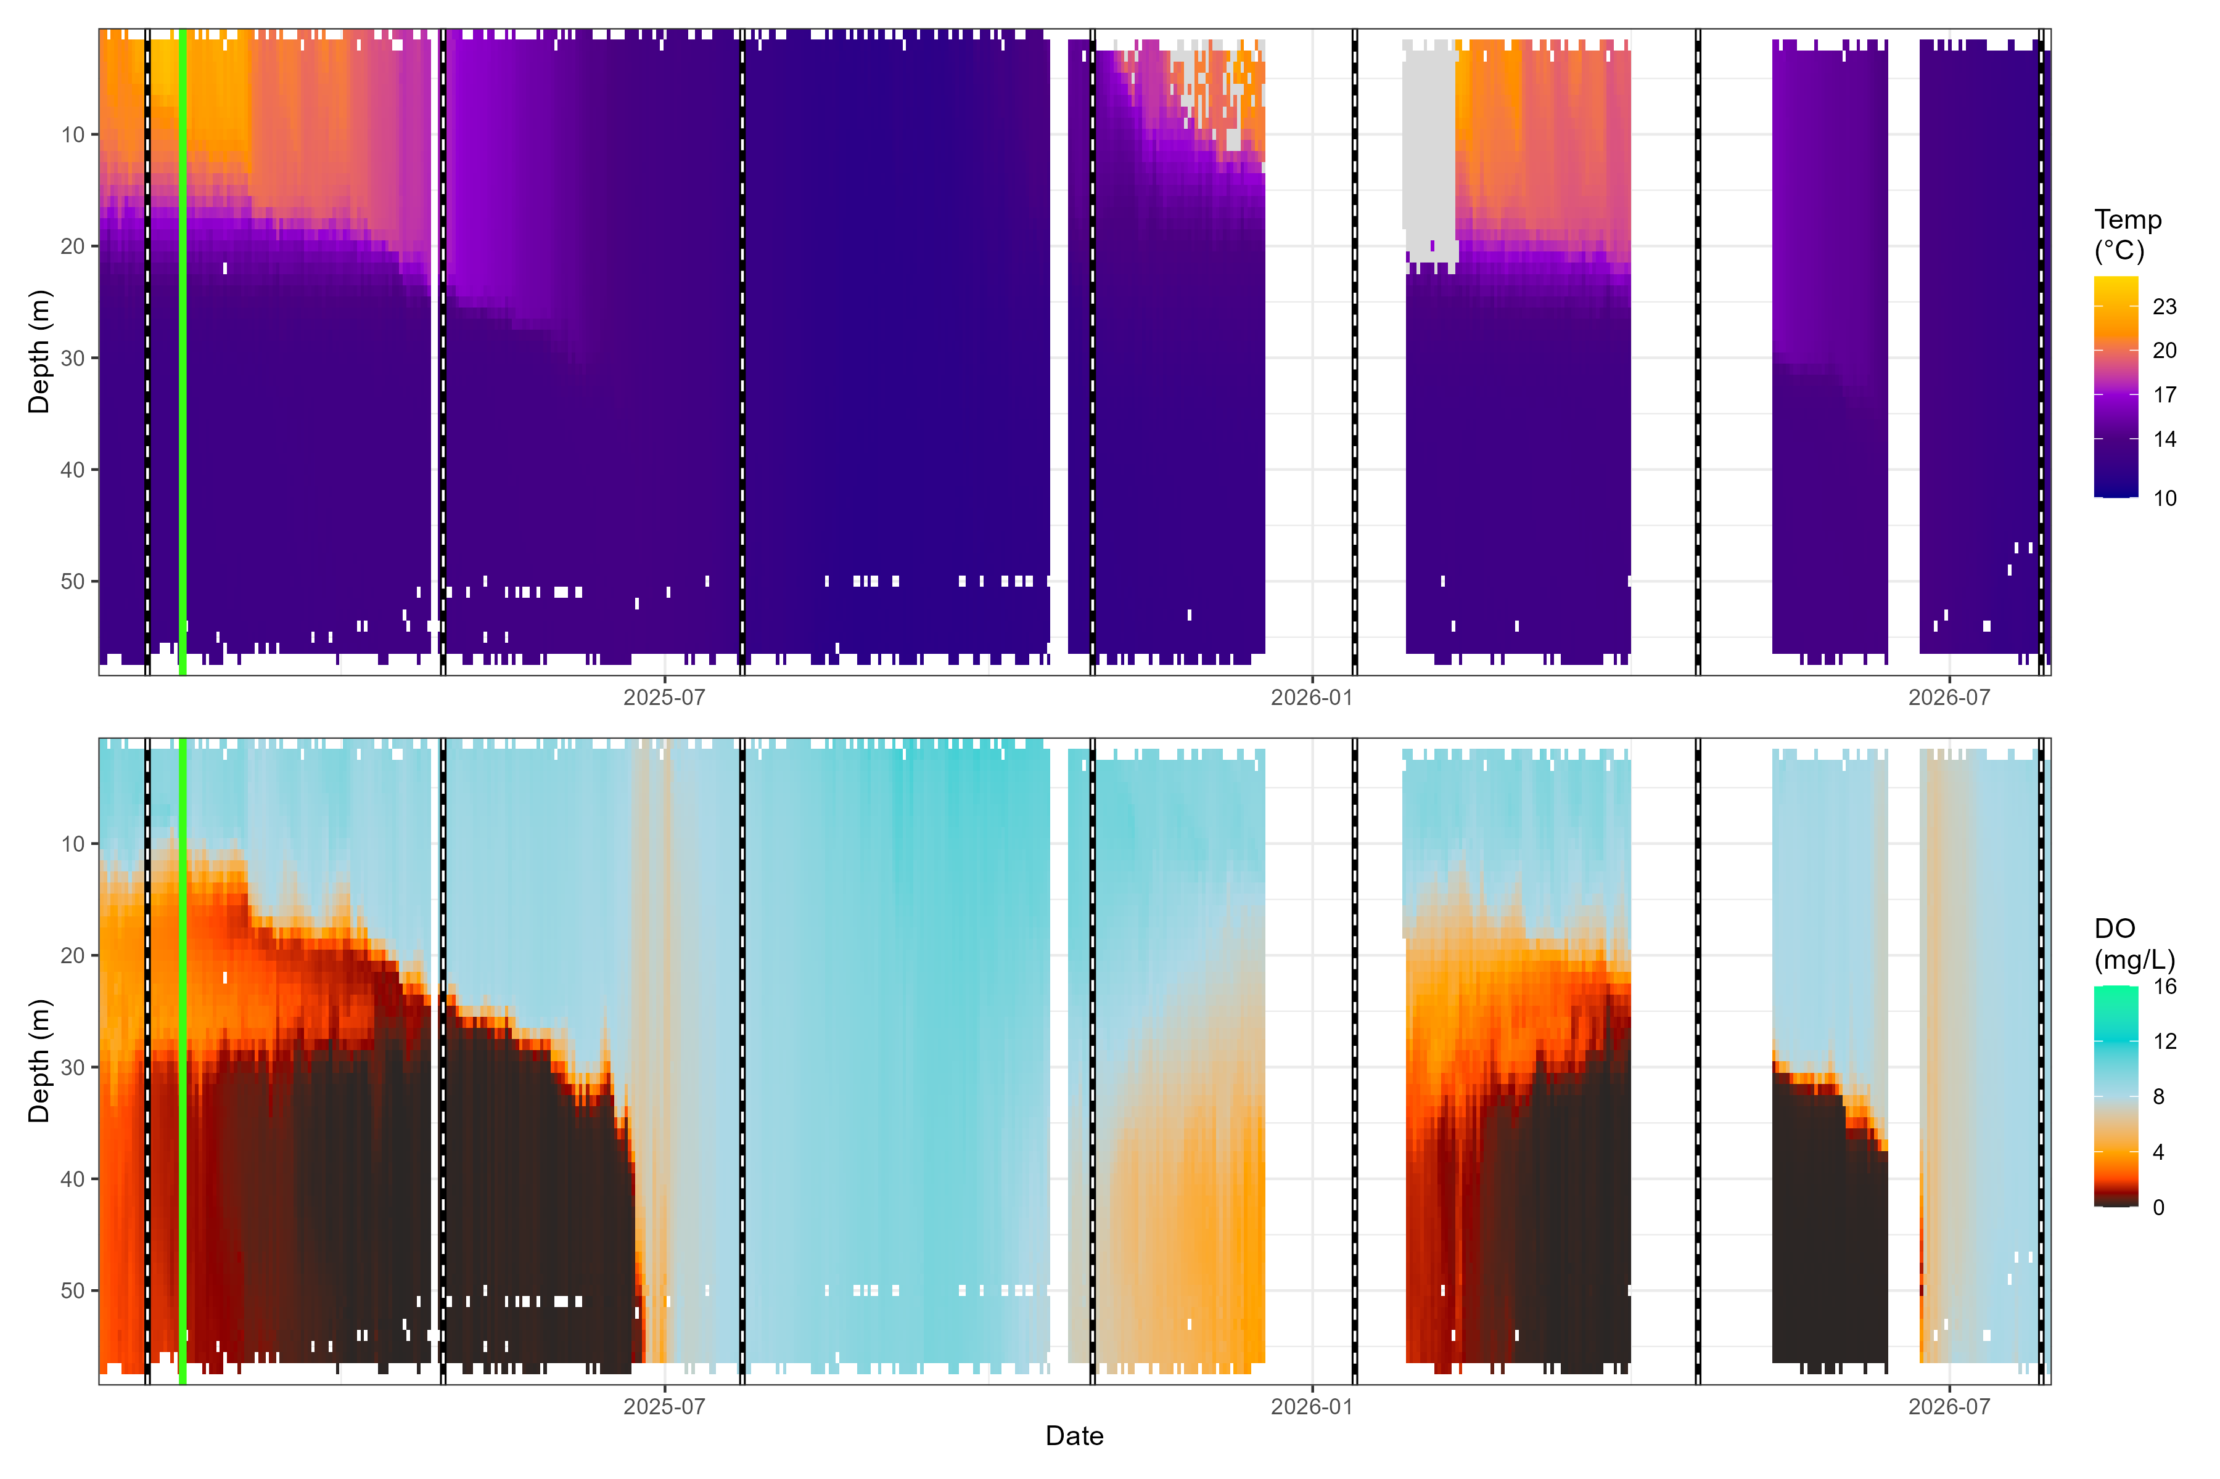 Figure S1: Depth-resolved water temperature (°C, top) and dissolved oxygen (mg/L, bottom) in Lake Rotoiti throughout the study period (February 2025 – July 2026). Data derived from the LimnoTrack continuous monitoring buoy (Moore & McBride, 2026). Vertical green line marks stone pile deployment; dashed vertical lines mark seasonal monitoring rounds. Warm colours in the DO panel (orange–black) indicate hypoxic and anoxic conditions (< 5 mg/L), demonstrating the pronounced summer stratification that compresses oxygenated habitat into the shallow littoral zone.
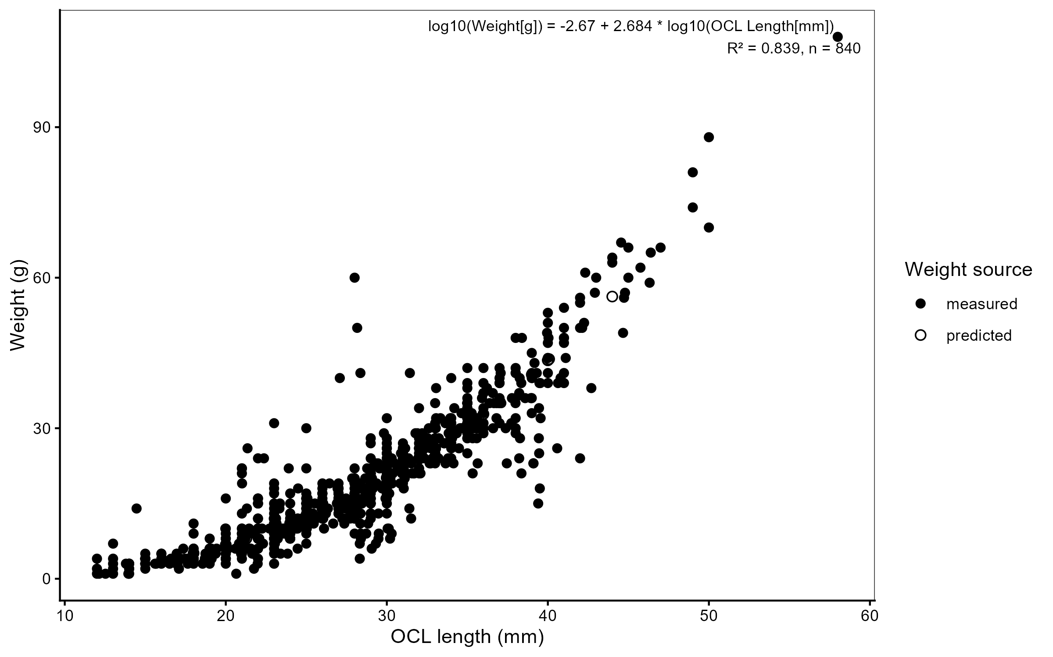
Figure S2: Length–weight relationship for kōura, fitted on log₁₀–log₁₀ scale. Open points are weights predicted from the length–weight regression (used to fill missing scale measurements); filled points are directly measured weights.

Table S1: Full fixed-effect estimates ($β$, SE, 95% CI, p-value) for every term in every model.
Model | RQ | Species | Response type | Comparison | Time frame | Term | Estimate | SE | Statistic | $p$​ | $p$ adj (BH) | 95% CI low | 95% CI high
M1aac | RQ1 | Catfish | abundance | treatment | before | (Intercept) | -2.303 | 0.908 | -2.535 | 0.011 | NA | -4.083 | -0.522
M1aac | RQ1 | Catfish | abundance | treatment | before | Site_type_detailStone_pile | -0.693 | 1.535 | -0.452 | 0.652 | 0.783 | -3.701 | 2.315
M1abc | RQ1 | Catfish | biomass | treatment | before | (Intercept) | 3.203 | 1.279 | 2.504 | 0.012 | NA | 0.696 | 5.709
M1abc | RQ1 | Catfish | biomass | treatment | before | Site_type_detailStone_pile | -5.100 | 3.107 | -1.641 | 0.101 | 0.403 | -11.190 | 0.990
M1aak | RQ1 | Kōura | abundance | treatment | before | (Intercept) | -1.897 | 0.785 | -2.415 | 0.016 | NA | -3.437 | -0.358
M1aak | RQ1 | Kōura | abundance | treatment | before | Site_type_detailStone_pile | 0.288 | 1.044 | 0.276 | 0.783 | 0.783 | -1.759 | 2.334
M1abk | RQ1 | Kōura | biomass | treatment | before | (Intercept) | 1.030 | 0.830 | 1.241 | 0.215 | NA | -0.597 | 2.656
M1abk | RQ1 | Kōura | biomass | treatment | before | Site_type_detailStone_pile | 1.044 | 0.977 | 1.068 | 0.286 | 0.571 | -0.872 | 2.959
M1bac | RQ1 | Catfish | abundance | reference | before | (Intercept) | -102.299 | 32.656 | -3.133 | 0.002 | NA | -166.303 | -38.295
M1bac | RQ1 | Catfish | abundance | reference | before | Site_type_detailReference_2 | -1.655 | 0.536 | -3.087 | 0.002 | 0.004 | -2.706 | -0.604
M1bac | RQ1 | Catfish | abundance | reference | before | Temperature | 4.079 | 1.293 | 3.154 | 0.002 | NA | 1.544 | 6.613
M1bbc | RQ1 | Catfish | biomass | reference | before | (Intercept) | -153.136 | 37.363 | -4.099 | 0.000 | NA | -226.366 | -79.906
M1bbc | RQ1 | Catfish | biomass | reference | before | Site_type_detailReference_2 | -2.569 | 0.743 | -3.457 | 0.001 | 0.002 | -4.026 | -1.112
M1bbc | RQ1 | Catfish | biomass | reference | before | Temperature | 6.315 | 1.482 | 4.261 | 0.000 | NA | 3.410 | 9.220
M1bak | RQ1 | Kōura | abundance | reference | before | (Intercept) | 0.742 | 0.553 | 1.343 | 0.179 | NA | -0.341 | 1.825
M1bak | RQ1 | Kōura | abundance | reference | before | Site_type_detailReference_2 | 0.031 | 0.778 | 0.040 | 0.968 | 0.968 | -1.494 | 1.557
M1bbk | RQ1 | Kōura | biomass | reference | before | (Intercept) | 3.623 | 0.478 | 7.580 | 0.000 | NA | 2.686 | 4.560
M1bbk | RQ1 | Kōura | biomass | reference | before | Site_type_detailReference_2 | -0.041 | 0.681 | -0.061 | 0.952 | 0.968 | -1.375 | 1.293
M2aac | RQ2a | Catfish | abundance | vs_control | full | (Intercept) | -3.976 | 1.631 | -2.438 | 0.015 | NA | -7.173 | -0.780
M2aac | RQ2a | Catfish | abundance | vs_control | full | PeriodAfter | 0.673 | 1.521 | 0.442 | 0.658 | NA | -2.308 | 3.654
M2aac | RQ2a | Catfish | abundance | vs_control | full | siteStone_pile | -0.639 | 1.762 | -0.362 | 0.717 | NA | -4.093 | 2.816
M2aac | RQ2a | Catfish | abundance | vs_control | full | monitoring_int | -0.294 | 0.344 | -0.853 | 0.394 | NA | -0.968 | 0.381
M2aac | RQ2a | Catfish | abundance | vs_control | full | fetch_z | -1.194 | 1.077 | -1.109 | 0.267 | NA | -3.305 | 0.916
M2aac | RQ2a | Catfish | abundance | vs_control | full | PeriodAfter:siteStone_pile | 2.002 | 1.973 | 1.015 | 0.310 | 0.858 | -1.864 | 5.869
M2abc | RQ2a | Catfish | biomass | vs_control | full | (Intercept) | 0.202 | 4.319 | 0.047 | 0.963 | NA | -8.262 | 8.667
M2abc | RQ2a | Catfish | biomass | vs_control | full | PeriodAfter | -0.340 | 2.404 | -0.141 | 0.888 | NA | -5.052 | 4.372
M2abc | RQ2a | Catfish | biomass | vs_control | full | siteStone_pile | -5.574 | 7.158 | -0.779 | 0.436 | NA | -19.604 | 8.456
M2abc | RQ2a | Catfish | biomass | vs_control | full | monitoring_int | -0.381 | 0.523 | -0.728 | 0.466 | NA | -1.406 | 0.644
M2abc | RQ2a | Catfish | biomass | vs_control | full | fetch_z | -1.675 | 2.438 | -0.687 | 0.492 | NA | -6.454 | 3.103
M2abc | RQ2a | Catfish | biomass | vs_control | full | PeriodAfter:siteStone_pile | 5.436 | 5.592 | 0.972 | 0.331 | 0.858 | -5.524 | 16.396
M2aoc | RQ2a | Catfish | occupancy | vs_control | full | (Intercept) | -2.185 | 1.887 | -1.158 | 0.247 | NA | -5.883 | 1.513
M2aoc | RQ2a | Catfish | occupancy | vs_control | full | PeriodAfter | -0.161 | 1.765 | -0.091 | 0.927 | NA | -3.621 | 3.299
M2aoc | RQ2a | Catfish | occupancy | vs_control | full | siteStone_pile | 0.024 | 1.982 | 0.012 | 0.990 | NA | -3.860 | 3.909
M2aoc | RQ2a | Catfish | occupancy | vs_control | full | monitoring_int | -0.165 | 0.259 | -0.635 | 0.525 | NA | -0.673 | 0.343
M2aoc | RQ2a | Catfish | occupancy | vs_control | full | fetch_z | -0.960 | 1.197 | -0.802 | 0.423 | NA | -3.306 | 1.387
M2aoc | RQ2a | Catfish | occupancy | vs_control | full | PeriodAfter:siteStone_pile | 0.387 | 2.168 | 0.179 | 0.858 | 0.858 | -3.863 | 4.637
M2aak | RQ2a | Kōura | abundance | vs_control | full | (Intercept) | -2.753 | 1.183 | -2.327 | 0.020 | NA | -5.072 | -0.434
M2aak | RQ2a | Kōura | abundance | vs_control | full | PeriodAfter | 2.374 | 0.976 | 2.432 | 0.015 | NA | 0.461 | 4.286
M2aak | RQ2a | Kōura | abundance | vs_control | full | siteStone_pile | 0.751 | 1.335 | 0.563 | 0.574 | NA | -1.865 | 3.368
M2aak | RQ2a | Kōura | abundance | vs_control | full | monitoring_int | -0.253 | 0.082 | -3.094 | 0.002 | NA | -0.413 | -0.093
M2aak | RQ2a | Kōura | abundance | vs_control | full | PeriodAfter:siteStone_pile | 0.311 | 1.232 | 0.253 | 0.800 | 0.858 | -2.104 | 2.727
M2abk | RQ2a | Kōura | biomass | vs_control | full | (Intercept) | 0.315 | 1.335 | 0.236 | 0.813 | NA | -2.301 | 2.931
M2abk | RQ2a | Kōura | biomass | vs_control | full | PeriodAfter | 2.248 | 1.246 | 1.805 | 0.071 | NA | -0.193 | 4.689
M2abk | RQ2a | Kōura | biomass | vs_control | full | siteStone_pile | 1.410 | 1.552 | 0.909 | 0.363 | NA | -1.631 | 4.451
M2abk | RQ2a | Kōura | biomass | vs_control | full | monitoring_int | -0.196 | 0.110 | -1.791 | 0.073 | NA | -0.412 | 0.019
M2abk | RQ2a | Kōura | biomass | vs_control | full | PeriodAfter:siteStone_pile | -0.336 | 1.471 | -0.228 | 0.819 | 0.858 | -3.220 | 2.548
M2aok | RQ2a | Kōura | occupancy | vs_control | full | (Intercept) | -0.690 | 1.643 | -0.420 | 0.674 | NA | -3.911 | 2.530
M2aok | RQ2a | Kōura | occupancy | vs_control | full | PeriodAfter | 1.913 | 1.556 | 1.230 | 0.219 | NA | -1.136 | 4.963
M2aok | RQ2a | Kōura | occupancy | vs_control | full | siteStone_pile | 0.013 | 2.121 | 0.006 | 0.995 | NA | -4.144 | 4.171
M2aok | RQ2a | Kōura | occupancy | vs_control | full | monitoring_int | -0.286 | 0.215 | -1.333 | 0.183 | NA | -0.708 | 0.135
M2aok | RQ2a | Kōura | occupancy | vs_control | full | PeriodAfter:siteStone_pile | 1.013 | 1.762 | 0.575 | 0.565 | 0.858 | -2.440 | 4.466
M2bac | RQ2b | Catfish | abundance | vs_control | after | (Intercept) | -2.150 | 1.519 | -1.416 | 0.157 | NA | -5.127 | 0.826
M2bac | RQ2b | Catfish | abundance | vs_control | after | siteStone_pile | -1.392 | 1.832 | -0.760 | 0.447 | NA | -4.983 | 2.199
M2bac | RQ2b | Catfish | abundance | vs_control | after | monitoring_int | -0.634 | 0.406 | -1.562 | 0.118 | NA | -1.430 | 0.162
M2bac | RQ2b | Catfish | abundance | vs_control | after | fetch_z | -1.097 | 0.976 | -1.124 | 0.261 | NA | -3.010 | 0.816
M2bac | RQ2b | Catfish | abundance | vs_control | after | siteStone_pile:monitoring_int | 0.831 | 0.557 | 1.492 | 0.136 | 0.215 | -0.261 | 1.922
M2bbc | RQ2b | Catfish | biomass | vs_control | after | (Intercept) | 2.964 | 2.725 | 1.088 | 0.277 | NA | -2.377 | 8.304
M2bbc | RQ2b | Catfish | biomass | vs_control | after | siteStone_pile | -4.522 | 4.240 | -1.066 | 0.286 | NA | -12.833 | 3.789
M2bbc | RQ2b | Catfish | biomass | vs_control | after | monitoring_int | -0.974 | 0.688 | -1.416 | 0.157 | NA | -2.323 | 0.374
M2bbc | RQ2b | Catfish | biomass | vs_control | after | fetch_z | -0.886 | 1.390 | -0.638 | 0.524 | NA | -3.610 | 1.837
M2bbc | RQ2b | Catfish | biomass | vs_control | after | siteStone_pile:monitoring_int | 1.357 | 0.974 | 1.393 | 0.164 | 0.215 | -0.552 | 3.266
M2boc | RQ2b | Catfish | occupancy | vs_control | after | (Intercept) | -0.952 | 1.737 | -0.548 | 0.584 | NA | -4.357 | 2.453
M2boc | RQ2b | Catfish | occupancy | vs_control | after | siteStone_pile | -2.013 | 1.936 | -1.040 | 0.298 | NA | -5.808 | 1.781
M2boc | RQ2b | Catfish | occupancy | vs_control | after | monitoring_int | -0.565 | 0.420 | -1.345 | 0.179 | NA | -1.388 | 0.258
M2boc | RQ2b | Catfish | occupancy | vs_control | after | fetch_z | -0.858 | 1.121 | -0.766 | 0.444 | NA | -3.055 | 1.339
M2boc | RQ2b | Catfish | occupancy | vs_control | after | siteStone_pile:monitoring_int | 0.735 | 0.546 | 1.344 | 0.179 | 0.215 | -0.336 | 1.806
M2bak | RQ2b | Kōura | abundance | vs_control | after | (Intercept) | 0.084 | 0.846 | 0.099 | 0.921 | NA | -1.573 | 1.741
M2bak | RQ2b | Kōura | abundance | vs_control | after | siteStone_pile | 0.323 | 0.808 | 0.400 | 0.689 | NA | -1.261 | 1.907
M2bak | RQ2b | Kōura | abundance | vs_control | after | monitoring_int | -0.409 | 0.143 | -2.861 | 0.004 | NA | -0.690 | -0.129
M2bak | RQ2b | Kōura | abundance | vs_control | after | siteStone_pile:monitoring_int | 0.243 | 0.179 | 1.359 | 0.174 | 0.215 | -0.107 | 0.593
M2bbk | RQ2b | Kōura | biomass | vs_control | after | (Intercept) | 3.270 | 0.856 | 3.821 | 0.000 | NA | 1.593 | 4.948
M2bbk | RQ2b | Kōura | biomass | vs_control | after | siteStone_pile | -0.077 | 0.986 | -0.078 | 0.938 | NA | -2.010 | 1.856
M2bbk | RQ2b | Kōura | biomass | vs_control | after | monitoring_int | -0.427 | 0.191 | -2.240 | 0.025 | NA | -0.800 | -0.053
M2bbk | RQ2b | Kōura | biomass | vs_control | after | siteStone_pile:monitoring_int | 0.366 | 0.239 | 1.531 | 0.126 | 0.215 | -0.103 | 0.834
M2bok | RQ2b | Kōura | occupancy | vs_control | after | (Intercept) | 1.585 | 1.885 | 0.841 | 0.400 | NA | -2.109 | 5.280
M2bok | RQ2b | Kōura | occupancy | vs_control | after | siteStone_pile | 0.563 | 2.660 | 0.212 | 0.832 | NA | -4.651 | 5.776
M2bok | RQ2b | Kōura | occupancy | vs_control | after | monitoring_int | -0.403 | 0.311 | -1.296 | 0.195 | NA | -1.014 | 0.207
M2bok | RQ2b | Kōura | occupancy | vs_control | after | siteStone_pile:monitoring_int | 0.229 | 0.441 | 0.519 | 0.604 | 0.604 | -0.636 | 1.094
M3aac | RQ3a | Catfish | abundance | vs_reference | after | (Intercept) | -7.151 | 1.282 | -5.577 | 0.000 | NA | -9.664 | -4.638
M3aac | RQ3a | Catfish | abundance | vs_reference | after | siteStone_pile | -2.471 | 1.940 | -1.274 | 0.203 | NA | -6.273 | 1.331
M3aac | RQ3a | Catfish | abundance | vs_reference | after | monitoring_int | -0.215 | 0.147 | -1.462 | 0.144 | NA | -0.504 | 0.073
M3aac | RQ3a | Catfish | abundance | vs_reference | after | Temperature | 0.315 | 0.058 | 5.414 | 0.000 | NA | 0.201 | 0.429
M3aac | RQ3a | Catfish | abundance | vs_reference | after | siteStone_pile:monitoring_int | 0.510 | 0.398 | 1.283 | 0.199 | 0.559 | -0.269 | 1.290
M3abc | RQ3a | Catfish | biomass | vs_reference | after | (Intercept) | 3.011 | 1.189 | 2.532 | 0.011 | NA | 0.681 | 5.342
M3abc | RQ3a | Catfish | biomass | vs_reference | after | siteStone_pile | -4.370 | 3.059 | -1.429 | 0.153 | NA | -10.366 | 1.626
M3abc | RQ3a | Catfish | biomass | vs_reference | after | monitoring_int | -0.250 | 0.209 | -1.196 | 0.232 | NA | -0.660 | 0.160
M3abc | RQ3a | Catfish | biomass | vs_reference | after | siteStone_pile:monitoring_int | 0.689 | 0.638 | 1.081 | 0.280 | 0.559 | -0.560 | 1.939
M3aak | RQ3a | Kōura | abundance | vs_reference | after | (Intercept) | 0.229 | 0.519 | 0.440 | 0.660 | NA | -0.789 | 1.247
M3aak | RQ3a | Kōura | abundance | vs_reference | after | siteStone_pile | 0.217 | 0.901 | 0.240 | 0.810 | NA | -1.550 | 1.984
M3aak | RQ3a | Kōura | abundance | vs_reference | after | monitoring_int | -0.090 | 0.056 | -1.612 | 0.107 | NA | -0.199 | 0.019
M3aak | RQ3a | Kōura | abundance | vs_reference | after | siteStone_pile:monitoring_int | -0.086 | 0.109 | -0.791 | 0.429 | 0.572 | -0.299 | 0.127
M3abk | RQ3a | Kōura | biomass | vs_reference | after | (Intercept) | 3.369 | 0.506 | 6.655 | 0.000 | NA | 2.377 | 4.361
M3abk | RQ3a | Kōura | biomass | vs_reference | after | siteStone_pile | -0.149 | 0.885 | -0.168 | 0.866 | NA | -1.884 | 1.586
M3abk | RQ3a | Kōura | biomass | vs_reference | after | monitoring_int | -0.088 | 0.074 | -1.177 | 0.239 | NA | -0.234 | 0.058
M3abk | RQ3a | Kōura | biomass | vs_reference | after | siteStone_pile:monitoring_int | 0.016 | 0.142 | 0.112 | 0.911 | 0.911 | -0.262 | 0.294
M3bac | RQ3b | Catfish | abundance | reference | after | (Intercept) | -7.372 | 1.705 | -4.324 | 0.000 | NA | -10.713 | -4.031
M3bac | RQ3b | Catfish | abundance | reference | after | Site_type_detailReference_2 | 0.753 | 1.007 | 0.747 | 0.455 | NA | -1.221 | 2.726
M3bac | RQ3b | Catfish | abundance | reference | after | monitoring_int | -0.130 | 0.220 | -0.591 | 0.555 | NA | -0.562 | 0.301
M3bac | RQ3b | Catfish | abundance | reference | after | Temperature | 0.304 | 0.073 | 4.183 | 0.000 | NA | 0.161 | 0.446
M3bac | RQ3b | Catfish | abundance | reference | after | Site_type_detailReference_2:monitoring_int | -0.151 | 0.287 | -0.527 | 0.598 | 0.797 | -0.714 | 0.411
M3bbc | RQ3b | Catfish | biomass | reference | after | (Intercept) | 2.726 | 1.556 | 1.752 | 0.080 | NA | -0.324 | 5.775
M3bbc | RQ3b | Catfish | biomass | reference | after | Site_type_detailReference_2 | 0.191 | 1.640 | 0.116 | 0.907 | NA | -3.024 | 3.406
M3bbc | RQ3b | Catfish | biomass | reference | after | monitoring_int | -0.227 | 0.301 | -0.754 | 0.451 | NA | -0.816 | 0.363
M3bbc | RQ3b | Catfish | biomass | reference | after | Site_type_detailReference_2:monitoring_int | 0.022 | 0.419 | 0.052 | 0.959 | 0.959 | -0.800 | 0.843
M3bak | RQ3b | Kōura | abundance | reference | after | (Intercept) | 0.380 | 0.790 | 0.480 | 0.631 | NA | -1.169 | 1.928
M3bak | RQ3b | Kōura | abundance | reference | after | Site_type_detailReference_2 | -0.115 | 0.570 | -0.202 | 0.840 | NA | -1.232 | 1.002
M3bak | RQ3b | Kōura | abundance | reference | after | monitoring_int | -0.019 | 0.062 | -0.302 | 0.763 | NA | -0.141 | 0.103
M3bak | RQ3b | Kōura | abundance | reference | after | SeasonSpring | -0.386 | 0.227 | -1.699 | 0.089 | NA | -0.831 | 0.059
M3bak | RQ3b | Kōura | abundance | reference | after | SeasonSummer | -0.330 | 0.233 | -1.416 | 0.157 | NA | -0.787 | 0.127
M3bak | RQ3b | Kōura | abundance | reference | after | SeasonWinter | -0.546 | 0.196 | -2.781 | 0.005 | NA | -0.932 | -0.161
M3bak | RQ3b | Kōura | abundance | reference | after | Site_type_detailReference_2:monitoring_int | -0.069 | 0.088 | -0.787 | 0.431 | 0.797 | -0.241 | 0.103
M3bbk | RQ3b | Kōura | biomass | reference | after | (Intercept) | 3.275 | 0.800 | 4.095 | 0.000 | NA | 1.707 | 4.842
M3bbk | RQ3b | Kōura | biomass | reference | after | Site_type_detailReference_2 | -0.067 | 0.670 | -0.100 | 0.920 | NA | -1.379 | 1.245
M3bbk | RQ3b | Kōura | biomass | reference | after | monitoring_int | -0.047 | 0.087 | -0.548 | 0.584 | NA | -0.217 | 0.122
M3bbk | RQ3b | Kōura | biomass | reference | after | Site_type_detailReference_2:monitoring_int | -0.074 | 0.125 | -0.591 | 0.554 | 0.797 | -0.319 | 0.171

Table S2: Baseline (pre-construction) comparability of stone pile, control, and reference sites. Values are mean ± SD; p-values test Stone pile vs Control (paired Wilcoxon signed-rank test) and Stone pile vs Reference (unpaired Wilcoxon rank-sum test).
Variable | Stone pile | Control | Reference | $p$ vs Control | $p$ vs Reference
Kōura CPUE | 0.2 ± 0.27 | 0.15 ± 0.22 | 2.13 ± 2.32 | 1.000 | 0.205
Catfish CPUE | 0.05 ± 0.11 | 0.1 ± 0.22 | 0.3 ± 0.52 | 1.000 | 0.420
Kōura BPUE | 7.95 ± 12.15 | 2.8 ± 3.84 | 36.69 ± 36.82 | 0.789 | 0.206
Catfish BPUE | 0.15 ± 0.34 | 24.6 ± 55.01 | 97.28 ± 232.15 | 1.000 | 0.343
Substrate index (before) | 3.39 ± 1.07 | 3.68 ± 0.95 | 5.29 ± 1.05 | 0.789 | 0.012
Substrate index (after) | 3.65 ± 1.12 | 3.68 ± 0.95 | 5.29 ± 1.05 | 1.000 | 0.032
Slope (0–20 m) | 0.06 ± 0.05 | 0.06 ± 0.04 | 0.09 ± 0.05 | 0.590 | 0.245
Temperature (°C) | 24.74 ± 1.92 | 24.78 ± 1.47 | 24.48 ± 0.78 | 1.000 | 0.623
Dissolved oxygen (mg/L) | 9.85 ± 1.48 | 9.63 ± 1.29 | 10.03 ± 0.86 | 0.418 | 0.426
Specific conductivity (µS/cm) | 195.44 ± 70.05 | 199.8 ± 78.52 | 165.45 ± 8.5 | 0.281 | 0.951
pH | 7.5 ± 2.15 | 7.61 ± 2.2 | 8.53 ± 0.66 | 1.000 | 0.426

Table S3: Posterior kōura occupancy probability ($ψ$) from the warm-season occupancy model (Summer and Autumn rounds). Values are population-level estimates averaged over random site effects, with 95 % credible intervals. Autumn has no Before period as baseline monitoring was conducted in summer only.
Season | Period | Site type | ψ (mean [95% CrI])
Summer | Before | Stone pile | 0.81 [0.26–1.00]
Summer | Before | Control | 0.82 [0.34–1.00]
Summer | Before | Reference 1 | 0.86 [0.36–1.00]
Summer | Before | Reference 2 | 0.89 [0.49–1.00]
Summer | After | Stone pile | 0.93 [0.64–1.00]
Summer | After | Control | 0.89 [0.53–1.00]
Summer | After | Reference 1 | 0.93 [0.62–1.00]
Summer | After | Reference 2 | 0.94 [0.67–1.00]
Autumn | After | Stone pile | 0.93 [0.69–1.00]
Autumn | After | Control | 0.88 [0.53–1.00]
Autumn | After | Reference 1 | 0.93 [0.65–1.00]
Autumn | After | Reference 2 | 0.92 [0.63–1.00]

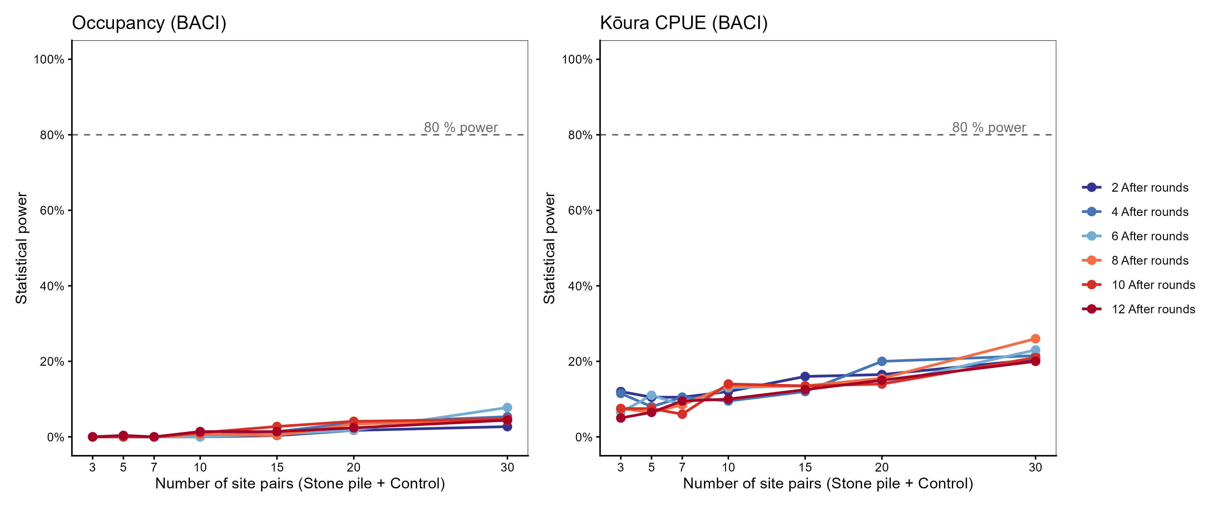
Figure S3: Simulation-based power curves for the occupancy BACI (left) and kōura CPUE BACI (right). Each line represents a different number of After-period monitoring rounds. Dashed line marks 80 % power.

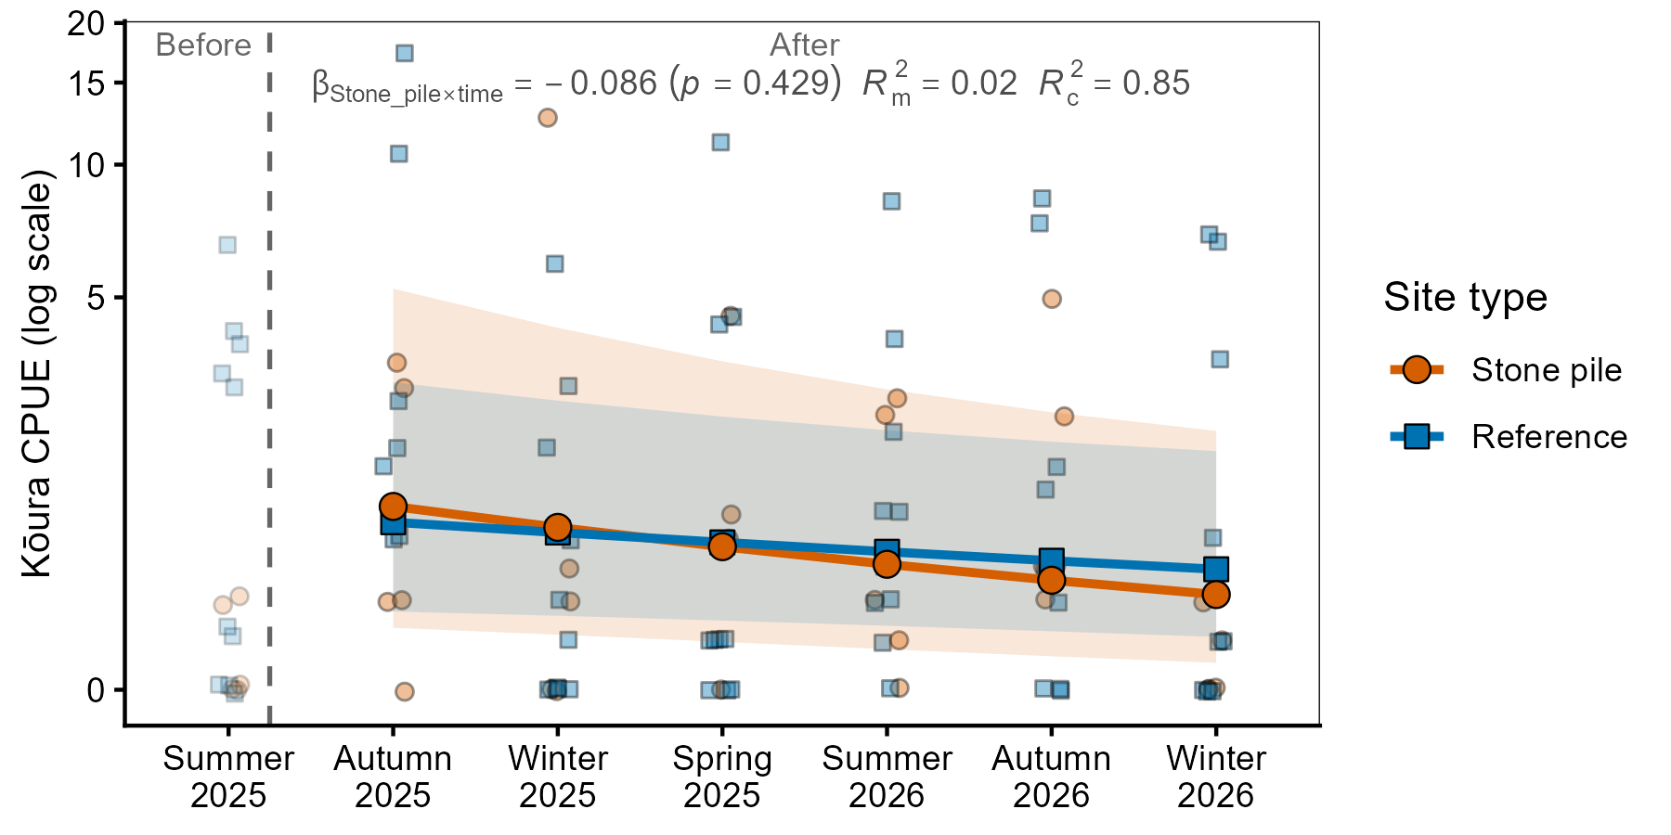 Figure S4: Predicted kōura CPUE trajectories over monitoring rounds at stone pile and reference sites from the abundance convergence model. Shaded ribbons represent 95% confidence intervals. The annotation shows the key interaction term ($β$ ± p-value) and model R² values for fixed effects (R²m) and conditional (R²c).

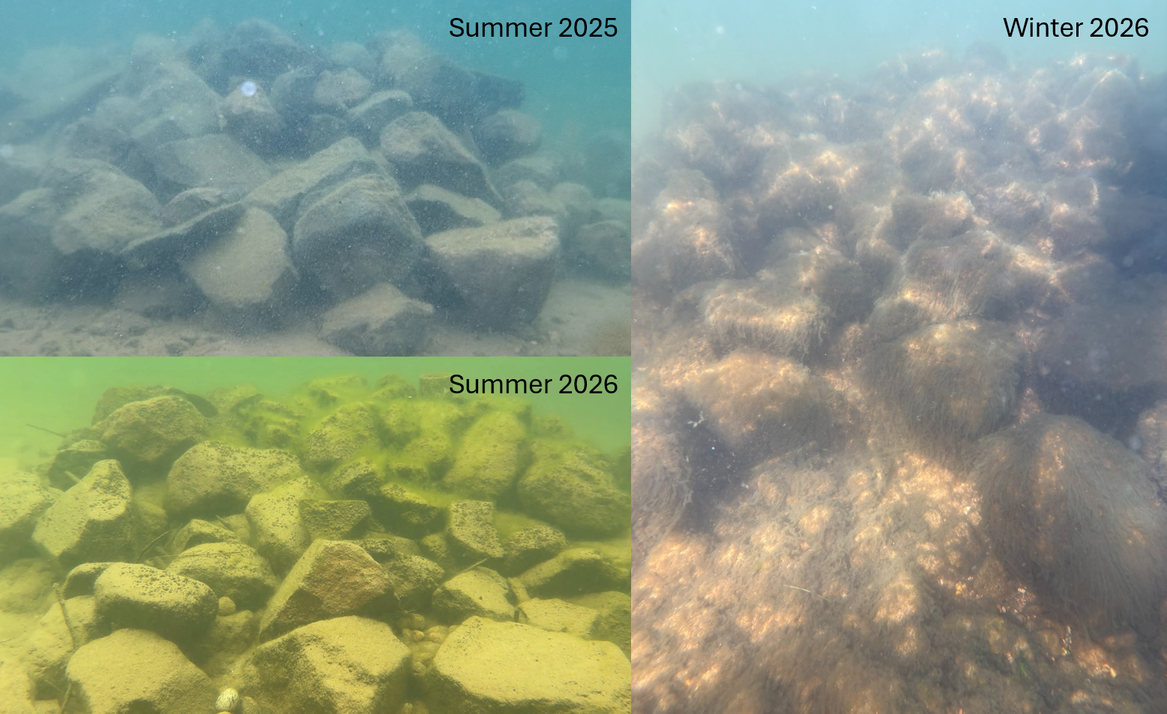
Figure S5: Progressive algal biofouling at stone pile site 9 in Lake Rotoiti across three monitoring periods. Summer 2025 (top left, shortly after construction) shows clean stone surfaces. Summer 2026 (bottom left) shows moderate biofilm accumulation is visible. Winter 2026 (right) shows extensive cover of stone surfaces by filamentous algae.

